

MindUP Home Activities Unit 1

The activities and ideas in this booklet complement the learning that is happening in school and will enable you to support your child further.

The MindUP programme is split into 4 units of work

**Unit 1 – Getting Focussed**

**Unit 2 – Sharpening your senses**

**Unit 3 – It’s all about attitude**

**Unit 4 – Taking action mindfully**

This handbook will give you tips and ideas of how best to support your child within Unit 1. We hope you will find it useful!

This unit is broken down into 3 lessons

Lesson 1 – How Our Brains Work

Lesson 2 – Mindful Awareness

Lesson 3 – Focussed Awareness: The Core Practice

**Unit 1 The MindUP Brain**

As a parent, understanding the links between the brain and behaviour can be enlightening. We can see our children’s behaviour more objectively when we are able to put it into a biological context. An understanding of your child’s developing brain can help to lower your parental frustration and increase the effectiveness of your responses. Learning a few key facts about the brain can optimize our ability to help our children navigate childhood and become successful adults. In the MindUP™ curriculum, children learn about four main parts of the brain: the Amygdala, the Pre-frontal Cortex, the Hippocampus, and the Reticular Activating System. Children of all ages love learning interesting facts about their brain. It is powerful for children to begin learning about their brain because it allows them to actively seek the optimal state for learning and being.

**Activity**

MindUP™ helps children understand how their brain works in an age-appropriate way. Using the analogy examples below, create your own analogy for the functions of the different parts of the MindUP™ brain:

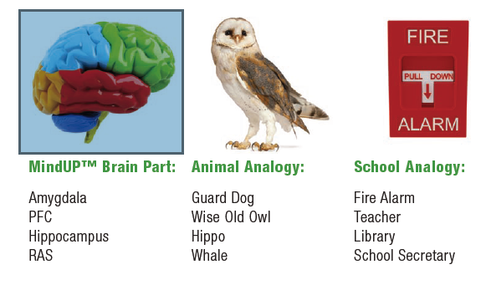

|  |  |
| --- | --- |
| **Family Activity Ideas – Conquering the Amygdala Hijack** | |
| Ages 3-6 | **Feeling Factory**  Help young children identify what they are feeling and how to describe it. Very often, behaviour difficulties (amygdala hijacks) are a result of a young child not having the words to describe what they are feeling and being overwhelmed.  Practice by acting out faces and guessing each other’s feelings so that children become more familiar with different expressions. |
| Ages 7-9 | **Settle your glitter!**  Take a small plastic jar/bottle with a screw on lid and fill it almost to the top with water. Add 1 tablespoon of glitter glue and 1 tablespoon of fine glitter. Screw the lid on tight and shake!  Talk with your child about how the jar is like your brain. Notice how hard it is to see clearly when the glitter is spinning. Compare it to when the amygdala is in charge and it’s hard to think clearly and make good decisions. When the glitter has settled compare it to what it’s like when the amygdala is calm and you can access your pre-frontal cortex and make good decisions. |
| Ages 10-11 | Have your child get familiar with things they can do to counter negative emotions. Some ideas might be exercise, deep breathing, writing feelings down, spending time with friends or family. |

|  |  |
| --- | --- |
| **Further Reading/Resources** | |
| Parents | Mindset: The new Psychology of Success  Carol Dweck |
| Children aged 4-6 | A Walk in the Rain with a Brain  Edward Hallowell |
| Children aged 7-11 | Your Fantastic Elastic Brain  JoAnn Deak  How does your brain work?  Don Curry |

**The Core Practice**

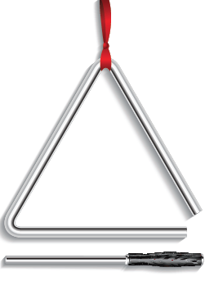Mindful awareness through focused attention is a valuable skill for both children and caregivers to learn and master. Children and adults who learn that mindful breathing helps to calm them down, which in turn allows them to think more clearly and act in a reflective manner, will be better able to regulate their emotions, reduce stress, and make better decisions. In school children have 3 core practice brain breaks a day.

**Learn how to take a brain break!**

1) Sit up tall, eyes down turned or closed

2) Listen for the chime (if using one)

3) Inhale through your nose and out your mouth

4) Fill the lungs fully, extending the breath to your abdomen.

5) Focus your attention on your breath (this could be as little as 3 breaths!)

6) Notice thoughts, return your attention to your breath

7) Listen for the chime a second time, and follow the resonant sound as long as you can

|  |  |
| --- | --- |
| **Family Activity Ideas – Teaching about the breath** | |
| Ages 3-6 | * Have your child lie down on the floor and have a beanbag/soft toy on their stomach. Instruct them to quietly watch the object rise and fall with their breath. * Blow bubbles together and watch them fall to the ground * Use pinwheels to practice using your breath making them go fast or slow. |
| Ages 7-9 | Use the ‘smell the flowers, blow out the candle’ image to help children develop the skill of focussing attention through breathing.  Use a focussing tool like a glitter wand or liquid timer to help your child practice mindful breathing, |
| Ages 10-11 | Cotton ball activity- each person has a cotton ball. Practice 1) blowing it past an object 2) blowing it to hit a target 3) practicing a gentle breath to push the cotton ball from the middle of the palm of the hand to the fingertips without letting it fall. |

|  |  |
| --- | --- |
| **Further Reading/Resources** | |
| Parents | Parenting from the Inside Out  By Dan Siegal and Mary Hartzell |
| Children aged 4-6 | Peaceful Piggy Meditation  By Kerry Lee  Cosmic Yoga  YouTube |
| Children aged 7-11 | Sitting Still Like a Frog: Mindfulness Exercises for Kids (and Their Parents) By Eline Snell |