MindUP Home Activities Unit 2
c
The activities and ideas in this booklet complement the learning that is happening in school and will enable you to support your child further.
The MindUP programme is split into 4 units of work
Unit 1 – Getting Focussed
Unit 2 – Sharpening your senses
Unit 3 – It’s all about attitude
Unit 4 – Taking action mindfully
This handbook will give you tips and ideas of how best to support your child within Unit 2. We hope you will find it useful!

This unit is broken down into 6 lessons

Lesson 4 – Mindful Listening
Lesson 5 – Mindful Seeing
Lesson 6 – Mindful Smelling
Lesson 7 – Mindful Tasting
Lesson 8 – Mindful Movement 1
Lesson 9 - Mindful Movement 2

Unit 2: Sharpening your Senses
What does it mean to awaken to our senses? It means to slow down enough to fully notice the world using our senses: seeing, listening, smelling, tasting and touching. Tuning into our senses, when practiced overtime,
It helps us to live in a more conscious state of mindful awareness and focused attention. This leads us to feel happier, healthier, less rushed and more engaged. To put it simply, our senses can be a practical short cut to mindful awareness. The MindUP™ mindful sensing activities include several techniques associated with increasing the dopamine levels in the brain. When dopamine levels increase, behaviours that become more prevalent include pleasure, motivation, self-awareness, alert awareness, focused attention, perseverance,
memory, and emotional resilience.

Mindful Listening
Help children understand that they can choose what they listen to and focus on (even when there are many sounds competing for their attention) will help them manage their behaviour, mood and social relationships. Practice it anywhere; the benefits will translate into other settings. “Did you hear the wind whistling through the trees?”
Family Activity Ideas – Mindful Listening
Ages 3-6 | Make your own shakers and fill them with different mystery sounds.
Ages 7-9 | Just close your eyes, and listen to what you can hear. You can ask children to identify five different sounds that they notice in the room/outside
Ages 10-11 | Listen to a song together and identify as many different instruments and voices as you can,

Mindful Seeing
Training your child to observe visual details requires coming from a posture of curiosity and the discipline of really looking at something you think you’ve already seen. Regardless of how familiar we are with something, there is always more to see.
Family Activity Ideas –
Ages 3-6 | Go on a family walk ‘treasure hunt’ Encouraging your child to look for treasures, these could be a certain colour leaf, rock etc.
Ages 7-9 | Look at a picture or a piece of art. Make a list of what you notice, colour, lines and details and feelings you have.
Ages 10-11 | In pairs face each other and mindfully notice what you pattern looks like. Turn around so your backs are to each other and then each person should change one thing about their appearance, eg. pull up a sleeve, remove some jewellery. Whoever notices first wins.

Mindful Smelling
The sense of smell is strongly linked with memory- the memory and smell centres in the brain are located near each other. In addition, different smells impact mood and energy level.
Family Activity Ideas – Mindful Smelling
Ages 3-6 | Take a mindful smelling walk around your area, such as a park, street with restaurants, bakery etc. Stop and notice each new smell
Ages 7-9 | Make your own mystery scents using opaque containers and fill them with cotton wool balls soaked with different scents. eg. lavender, oranges etc
Ages 10-11 | Discuss together 3-5 of your favourite scents and share the memories associated with each scent.

Mindful tasting
Taking time to savour our food and appreciate the flavours, the textures and the temperature is a pleasure that is available to us every day but rarely enjoyed. Eating mindfully has implications for our health and well-being.
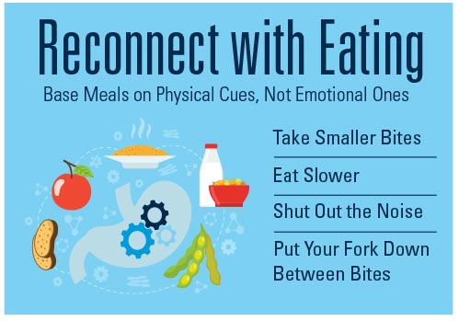

Family Activity Ideas – Mindful Tasting
Ages 3-6 | Conduct a blind taste test of each food on your child’s plate at dinner
Ages 7-9 | Have your child to create a menu they would enjoy eating mindfully. Include beverages and desert. Have them describe flavours and textures that would make this meal worth savouring.
Ages 10-11 | Choose one day a week where your child is in charge of making dinner. Help them plan their menu and prepare. Throughout the process, draw their attention to the sensory rich moments. Mindfully taste together a morsel of each food they prepare.

Further Reading/Resources
Parents | Coming to Our Senses: Healing Ourselves and  the World through Mindfulness  By Jon Kabat Zinn
Children aged 4-7 | The Monster Health Book: A Guide to Eating Healthy, Being Active & Feeling Great for Monsters & Kids!  By Edward Miller
Children aged 7-11 | No Ordinary Apple: A Story about Eating Mindfully  By Sara Marlowe
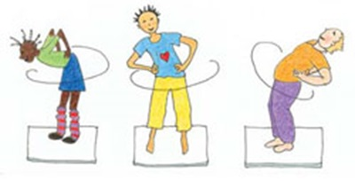
Mindful Movement

There are few things in the world that are beyond dispute. One is that exercise and moving our bodies is valuable for all of us. The physical benefits have been chronicled for many years: lower blood pressure, healthier hearts etc. There is a body of research that confirms a significant link between physical exercise and positive academic, mental health and social outcomes. No matter what it looks like to your family, how can you “move a body” every day?
Family Activity Ideas – Mindful Movement
Ages 3-6 | Teach your child to balance a beanbag on their head and raise a knee to create a balancing position. Remain for 60 seconds, breathing deeply, and notice the sensations in the body.
Ages 7-9 | Do a ‘dopamine dance’ put on music that makes you happy and enjoy wiggling, turning and shaking your bodies, and dancing together.
Ages 10-11 | Play ‘jenga’ as a family. Take turns mindfully moving the blocks.

Further Reading/Resources
Parents | Mindful Mornings for you: A movement to encourage and inspire you  By Patti Bryant
Children aged 4-6 | Slowly, Slowly, Slowly,” said the Sloth  By Eric Carle  Mindful Movements: Mindfulness Exercises Developed by Thich Nhat Hanh and the Plum Village Sangha  By Thich Nhat Hanh and Wietske Vriezen
Children aged 7-11 | Earthdance  By Joanne Ryder

