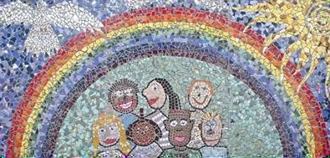

MindUP Home Activities Unit 4

The activities and ideas in this booklet complement the learning that is happening in school and will enable you to support your child further.
The MindUP programme is split into 4 units of work
Unit 1 – Getting Focussed
Unit 2 – Sharpening your senses
Unit 3 – It’s all about attitude
Unit 4 – Taking action mindfully
This handbook will give you tips and ideas of how best to support your child within Unit 4. We hope you will find it useful!
This unit is broken down into 3 lessons
Lesson 13 – Expressing Gratitude
Lesson 14 – Performing Acts of Kindness
Lesson 15 – Taking Mindful Action in the World

Unit 4 – Taking Action Mindfully
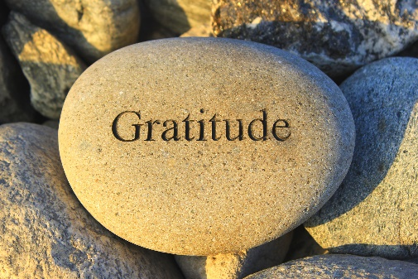
By expressing gratitude and performing acts of kindness, students develop a stronger understanding if the feelings of other people and a concern for the well-being of others. Research shows that actions that engender feelings of empathy and compassion have a number of positive benefits, such as boosting the production of the feel good neurotransmitter dopamine, increasing the likelihood that children will continue to act on their social concerns and improving their capacity to take care of themselves.
Lesson 13- Expressing Gratitude

Simply focusing for a minute on the experiences in our lives we’re grateful for shifts our thinking to a calmer, more content perspective, which can immediately uplift and comfort us. When we make expression of gratitude as a family a regular practice, we train our brains to shift to a positive mind-set more efficiently and maintain a healthier, more optimistic perspective. Sharing gratitude as a family helps to forge stronger bonds, greater trust, and increases empathy.

Family Activity Ideas – Perspective Taking
Ages 3-6 | Gratitude Chain- Cut strips of colourful paper and place them in a basket. Start a gratitude chain where each person in the family writes down something they are grateful for. Loop the strips together and watch your gratitude chain grow.
Ages 7-9 | Gratitude Letter – Invite your child to write a letter to an important person in their life and express gratitude for the influence and/or happiness this person brings. Encourage your child to be specific about the (non-material) gifts he sees in this person. The impact of this activity will be even greater if your child hand delivers this special letter!
Ages 10-11 | 3 Good Things – Encourage your children to action 3 good things and watch as the kindness spreads to others!

Further Reading/Resources
Parents | Thanks!: How the New Science of Gratitude Can Make You Happier  By Robert Emmons
Children aged 4-6 | The Thankful Book  By Todd Carr  Thankful  By Eileen Spinelli
Children aged 7-11 | Make a Gratitude Journal

Lesson 14 – Performing Acts of Kindness
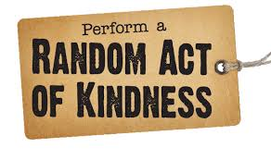
We actually have the ability to train our brains to actively savour happy experiences in order to reap the benefits. Focusing on the positive is not just a “sentimental idea” but is actually grounded in current neuroscience. Our brains release dopamine (a feel good neurotransmitter) when we remember a happy experience changes the way our brains are wired and impacts how we feel, think, and behave.

The most powerful thing you can do is model kindness to yourself, your family and others. If you have moments of unkind reactions, pay attention, ask yourself what’s going on and then get back on track by making a repair. Your kids will learn from your example. Language is powerful. Set an intention to use kind words throughout the day (especially in ear shot of your children) such as: generous, helpful, warm, loving, gentle, understanding, respectful, nurturing, friendly.

Family Activity Ideas – Choosing Optimism
Ages 3-6 | ‘Magic Kindness Wand’ - Create a special magic wand from a stick that your child might use to spread kindness. When they touch a family member with the wand, the family  member must say something kind or have a suggestion of how they could extend a kindness to someone else.
Ages 7-9 | 5 Kind things – Get child to record 5 acts of kindness on a piece of paper and challenge them to complete all acts by the end of the day.
Ages 10-11 | BFF Power-point - Encourage your child to get creative and make a PowerPoint which could include uplifting pictures and quotes and then  deliver by email.

Further Reading/Resources
Parents | Neural Correlates of Admiration and Compassion  By Mary Helen Immordino Yang, Andrea McColl, Hanna Damasio and Antonio Demasio
Children aged 4-6 | Ordinary Mary's Extraordinary Deed  By Emily Pearson
Children aged 7-11 | The Giving Tree  By Shel Silverstein

Lesson 15 – Taking Mindful Action in the World

When parents are asked what they want for their children, a common answer is “I want them to be happy and I want them to contribute to their community.” Mindful awareness, compassion, optimism and gratitude come to maturity when we integrate these qualities and take mindful action in the world.

Family Activity Ideas – Appreciating Happy Experiences
Ages 3-6 | Walk around your neighbourhood and look for opportunities to be a good citizen by picking up some rubbish etc.
Ages 7-11 | Imagine that you are the leader of a group doing an act of kindness for the Earth. What part of the world will the act focus on? Describe your plan for environmental kindness.

Further Reading/Resources
Parents | 10 Mindful Minutes: A Journal  Goldie Hawn
Children aged 4-6 | I can Make a Difference  By Marian Wright Edelman
Children aged 7-11 | Giant Steps to Change the World  By Spike Lee

